Calculate Benchmark Averages Across All Channels
Computes average baseline benchmarks across all acquisition channels to compare against.
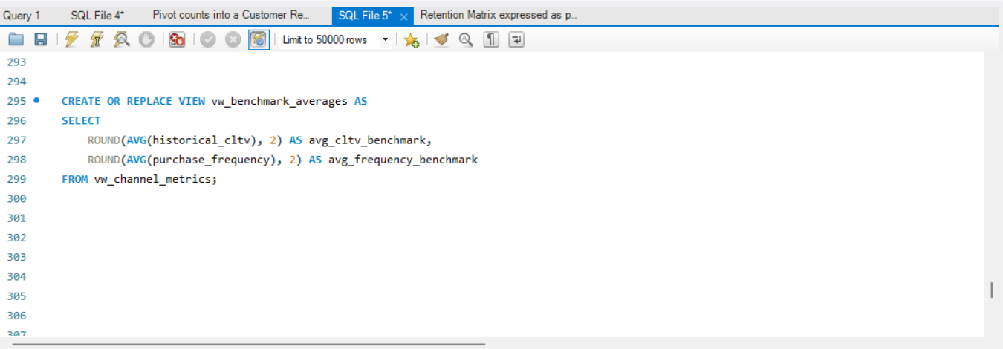
Benchmark calculations

QUERY-;

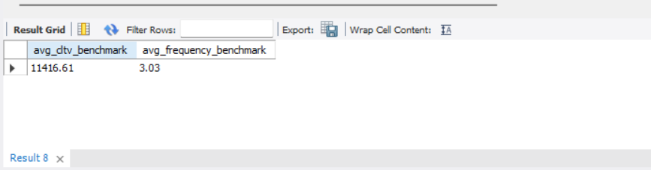
OUTPUT-;

